Principles of Programming Languages Lab (MCP542-1)

M.C.A.-Semester-I

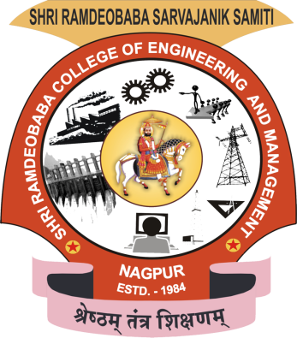

Session: 2020-21

Shri Ramdeobaba College of Engineering and Management, Gittikhadan,Katol Road,

Nagpur 440013 (M.S.)

Shri Ramdeobaba College of Engineering and Management, Nagpur

Department of Computer Application

**Course Objectives**

The objective of the course is to prepare the students:

1. To enable the development of skills through which the student will gain expertise in various programming language standards.
2. To develop skills to design and implement algorithms for implementing different features of programming languages like dynamic memory Management.
3. To inculcate consciousness and capability to analyze application at hand by selecting appropriate programming language for designing and development of that application.

**Course Outcomes**

On successful completion of the course, students will be able to:

1. Describe different programming language paradigms and demonstrate their utility as well as enumerate different features present in modern programming languages.
2. Design and implement algorithms for implementing different features of programming languages like dynamic memory Management.
3. Analyze an application at hand, choose an appropriate programming language for it and design and develop the application for the chosen language.

**Syllabus**

Minimum 8 practicals and assignments based on but not limited to the following topics:

* Implementation of various Data Types.
* Heap Management with various strategies.
* Implementation of Function Calling, Exception Handling mechanism, Inheritance Mechanism and Access Specifiers.
* Control Flow in Looping Structures

.

**Name of Student:**

**Shift:**

**Roll Number:**

**Batch No:**

**Name of Program:**

**Source Code:**

**Output:**

**Note:-**

* + - 1. **Please take the screenshot for output.**
      2. **Submit in the pdf format only**
      3. **File name must be in below format**

BatchNo-RollNo-NameofStudnet.pdf.

Ex: B2_25_RajaRam.pdf